|  |  |
| --- | --- |
| **Ex. No 1** | **Linux Commands** |
| **16th July** |

**Aim: To understand basic linux commands**

**Result:** Linux Commands were executed

|  |  |
| --- | --- |
| **Ex. No 2** | **Install Hadoop** |
|  |

**Aim: To install Hadoop in the working system**

**Output:**

**Result:** Hadoop was successfully installed on the PC

|  |  |
| --- | --- |
| **Ex. No: 3** | **Implementing MapReduce** |
| **30th July** |

**Aim: To Implement a simple map-reduce code for the wordcount problem using Java/Python.**

**Program:**

Mapper.py

#!/usr/bin/env python3

import sys

for line in sys.stdin:

    fields = line.strip().split()

    if len(fields) >= 8:

        date = fields[1]

        max_temp = fields[7]

        min_temp = fields[6]

        try:

            print(f"{date}\t{max_temp}\t{min_temp}")

        except ValueError:

            continue

Reducer.py

#!/usr/bin/env python3

import sys

current_date = None

current_max_temp = float('-inf')

current_min_temp = float('inf')

for line in sys.stdin:

    line = line.strip()

    date, max_temp, min_temp = line.split("\t")

    try:

        max_temp = float(max_temp)

        min_temp = float(min_temp)

    except ValueError:

        continue

    if current_date == date:

        current_max_temp = max(current_max_temp, max_temp)

        current_min_temp = min(current_min_temp, min_temp)

    else:

        if current_date:

            print(f"{current_date}\t{current_max_temp}\t{current_min_temp}")

        current_date = date

        current_max_temp = max_temp

        current_min_temp = min_temp

if current_date:

    print(f"{current_date}\t{current_max_temp}\t{current_min_temp}")

**Output:**

**Result: Thus map reduce program is implemented using python**

|  |  |
| --- | --- |
| **Ex. No: 4** | **Implementing MapReduce2** |
| **6th Aug** |

**Aim: To understand how map reduce program works using Apriori algorithm**

**Program:**

Mapper.py

import sys

from itertools import combinations

def generate_combinations(items, k):

    return combinations(sorted(set(items)), k)

k = 3

for line in sys.stdin:

    items = line.strip().split()[1:]

    item_combinations = generate_combinations(items, k)

    for itemset in item_combinations:

        print(f"{','.join(itemset)}\t1")

Reducer.py

import sys

current_itemset = None

current_count = 0

min_support = 2

for line in sys.stdin:

    itemset, count = line.strip().split("\t")

    count = int(count)

    if current_itemset == itemset:

        current_count += count

    else:

        if current_itemset and current_count >= min_support:

            print(f"{current_itemset}\t{current_count}")

        current_itemset = itemset

        current_count = count

if current_itemset and current_count >= min_support:

    print(f"{current_itemset}\t{current_count}")

**Output:**

**Result: Thus Apriori implemented using the map reduce program**

|  |  |
| --- | --- |
| **Ex. No: 5** | **Spark and PySpark** |
| **16th August** |

**Aim: To Install and understand the usage of the Pyspark**

**Program:**

Word_count.py

from pyspark import SparkContext

# Initialize SparkContext

sc = SparkContext("local", "Word Count")

# Read the file

text_file = sc.textFile("u.txt")

# Perform word count

counts = text_file.flatMap(lambda line: line.split("\t")) \

                  .map(lambda word: (word, 1)) \

                  .reduceByKey(lambda a, b: a + b)

# Collect the results

output = counts.collect()

# Print the output

for (word, count) in output:

    print(f"{word}: {count}")

# Stop the SparkContext

sc.stop()

movie_rating.py

from pyspark import SparkContext

# Initialize SparkContext

sc = SparkContext("local", "Movie Ratings Distribution")

# Read the file

text_file = sc.textFile("u.txt")

# Parse the lines to extract movie ID and rating

movie_ratings = text_file.map(lambda line: line.split("\t")) \

                         .map(lambda fields: (fields[1], int(fields[2])))

# Count the number of each rating for each movie

ratings_distribution = movie_ratings.map(lambda x: ((x[0], x[1]), 1)) \

                                    .reduceByKey(lambda a, b: a + b) \

                                    .map(lambda x: (x[0][0], (x[0][1], x[1]))) \

                                    .groupByKey() \

                                    .mapValues(list)

# Collect and print the results

output = ratings_distribution.collect()

for (movie_id, ratings) in output:

    print(f"Movie ID: {movie_id}, Ratings Distribution: {ratings}")

# Stop the SparkContext

sc.stop()

**Output:**

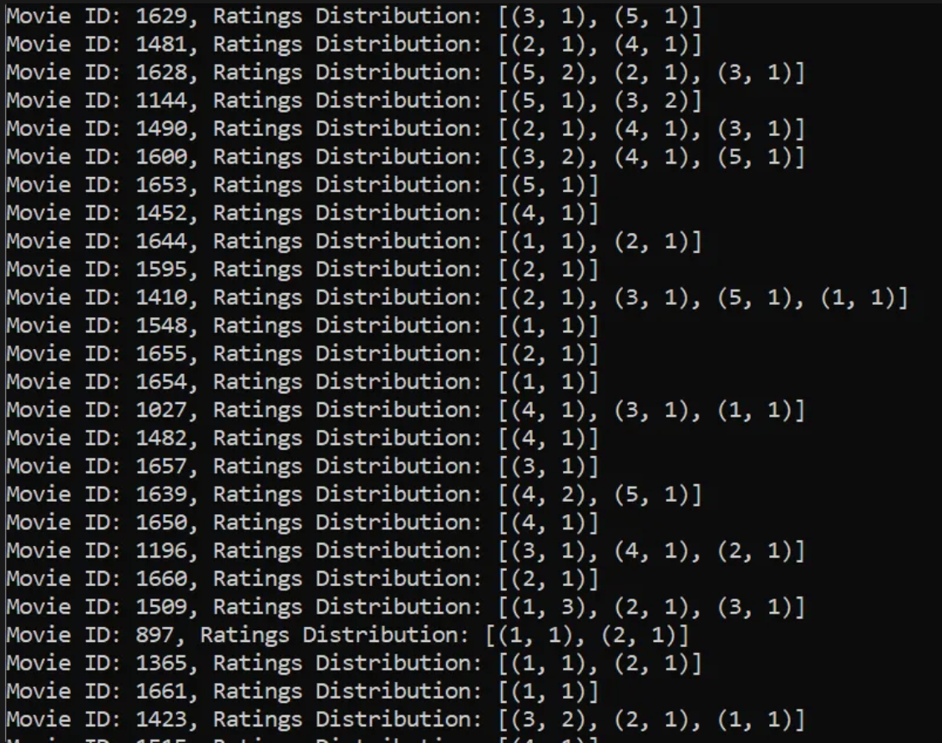

**Result: Required results achieved by performing following codes**

|  |  |
| --- | --- |
| **Ex. No: 6** | **PySpark** |
| **20th August** |

**Aim: To understand map values of RDD in spark**

**Program:**

Q1

from pyspark import SparkContext

sc = SparkContext("local", "Friends Average")

data = sc.textFile("friends_test.csv").map(lambda line: line.split(","))

age_friends_rdd = data.map(lambda x: (int(x[2]), int(x[3])))

combined = age_friends_rdd.combineByKey(

    lambda friends: (friends, 1),

    lambda acc, friends: (acc[0] + friends, acc[1] + 1),

    lambda acc1, acc2: (acc1[0] + acc2[0], acc1[1] + acc2[1])

)

average_friends_rdd = combined.mapValues(lambda x: x[0] / x[1])

results = average_friends_rdd.collect()

for age, avg_friends in results:

    print(f"Age: {age}, Average Number of Friends: {avg_friends}")

sc.stop()

Q2

from pyspark import SparkContext

sc = SparkContext("local", "Temperature Analysis")

data = sc.textFile("temp.csv").zipWithIndex().filter(lambda x: x[1] != 0).map(lambda x: x[0].split(","))

temp_rdd = data.map(lambda x: (x[0], x[1], x[2], int(x[3])))

tmin_rdd = temp_rdd.filter(lambda x: x[2] == "TMIN")

overall_min_temp = tmin_rdd.map(lambda x: x[3]).min()

print(f"Overall Minimum Temperature: {overall_min_temp}")

min_temp_per_itemID = tmin_rdd.map(lambda x: (x[0], x[3])).reduceByKey(lambda a, b: min(a, b))

print("Minimum Temperature for each ItemID:")

for itemID, min_temp in min_temp_per_itemID.collect():

    print(f"ItemID: {itemID}, Minimum Temperature: {min_temp}")

min_temp_per_stationID = tmin_rdd.map(lambda x: (x[1], x[3])).reduceByKey(lambda a, b: min(a, b))

print("Minimum Temperature for each StationID:")

for stationID, min_temp in min_temp_per_stationID.collect():

    print(f"StationID: {stationID}, Minimum Temperature: {min_temp}")

sc.stop()

Q3

from pyspark import SparkContext

sc = SparkContext("local", "Temperature Analysis")

data = sc.textFile("temp.csv").zipWithIndex().filter(lambda x: x[1] != 0).map(lambda x: x[0].split(","))

temp_rdd = data.map(lambda x: (x[0], x[1], x[2], int(x[3])))

tmax_rdd = temp_rdd.filter(lambda x: x[2] == "TMAX")

overall_max_temp = tmax_rdd.map(lambda x: x[3]).max()

print(f"Overall Maximum Temperature: {overall_max_temp}")

max_temp_per_itemID = tmax_rdd.map(lambda x: (x[0], x[3])).reduceByKey(lambda a, b: max(a, b))

print("Maximum Temperature for each ItemID:")

for itemID, max_temp in max_temp_per_itemID.collect():

    print(f"ItemID: {itemID}, Maximum Temperature: {max_temp}")

max_temp_per_stationID = tmax_rdd.map(lambda x: (x[1], x[3])).reduceByKey(lambda a, b: max(a, b))

print("Maximum Temperature for each StationID:")

for stationID, max_temp in max_temp_per_stationID.collect():

    print(f"StationID: {stationID}, Maximum Temperature: {max_temp}")

sc.stop()

**Output:**

**Result: The required output is achieved using pyspark**

|  |  |
| --- | --- |
| **Ex. No: 9** | **EC2** |
| **10th September** |

**Aim: To create and EC2 Instance on the AWS**

**Program:**

- Go to Instances in EC2

- Launch Instance

- Configure the Snapshots needed

- Connect to the instance

- Sudo apt update

- Sudo apt install apache2

- service apache2 status

- cd /var/www/html/

- sudo chmod 777 index.html

- Change the index file

- copy the public IP and paste on the browser (get results)

**Output:**

**Result:**

Thus using AWS, we have successfully created an EC2 Instance

|  |  |
| --- | --- |
| **Ex. No: 10** | **Route53** |
| **1st October** |

**Aim: To perform DNS mapping using Route 53 service in AWS**

**Program:**

- Start the AWS Akshay S G Instance

- Go to Godaddy

- Create a NS record by rollnumber (21011101079) and the value with one from the AWS route 53 service (.com)

- Comeback to AWS create a record with www. and simple routing policy

- nslookup 21011101079.ngaws.xyz

- links 21011101079.ngaws.xyz

**Output:**

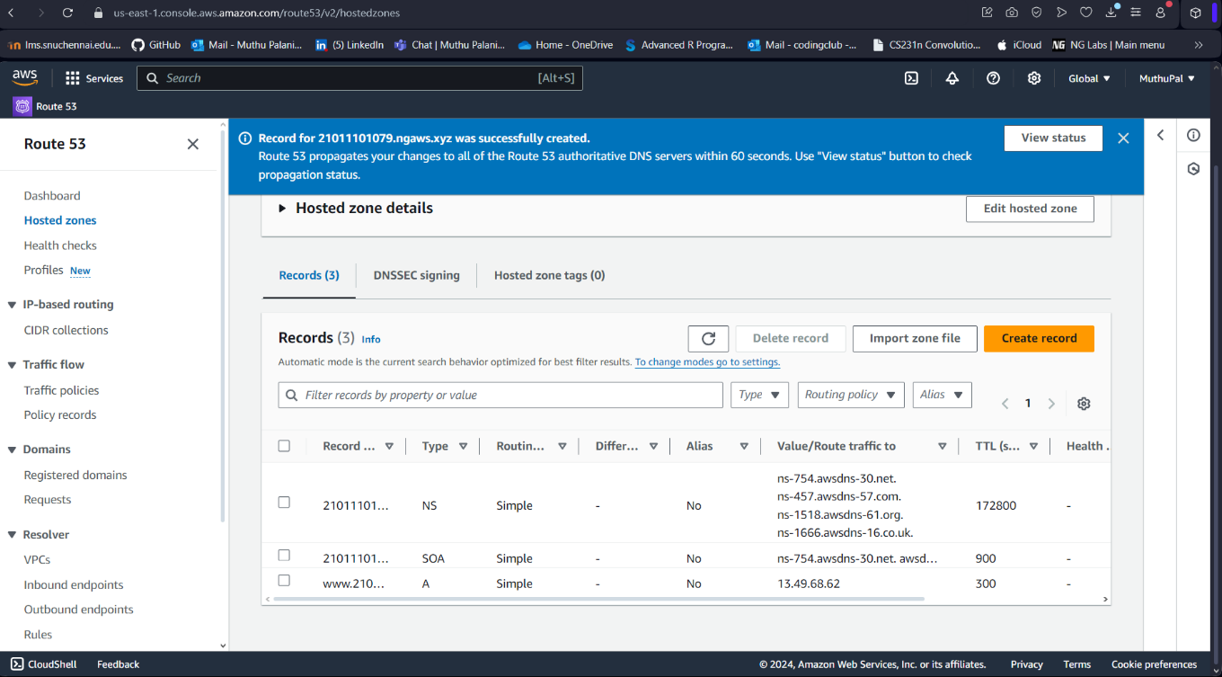

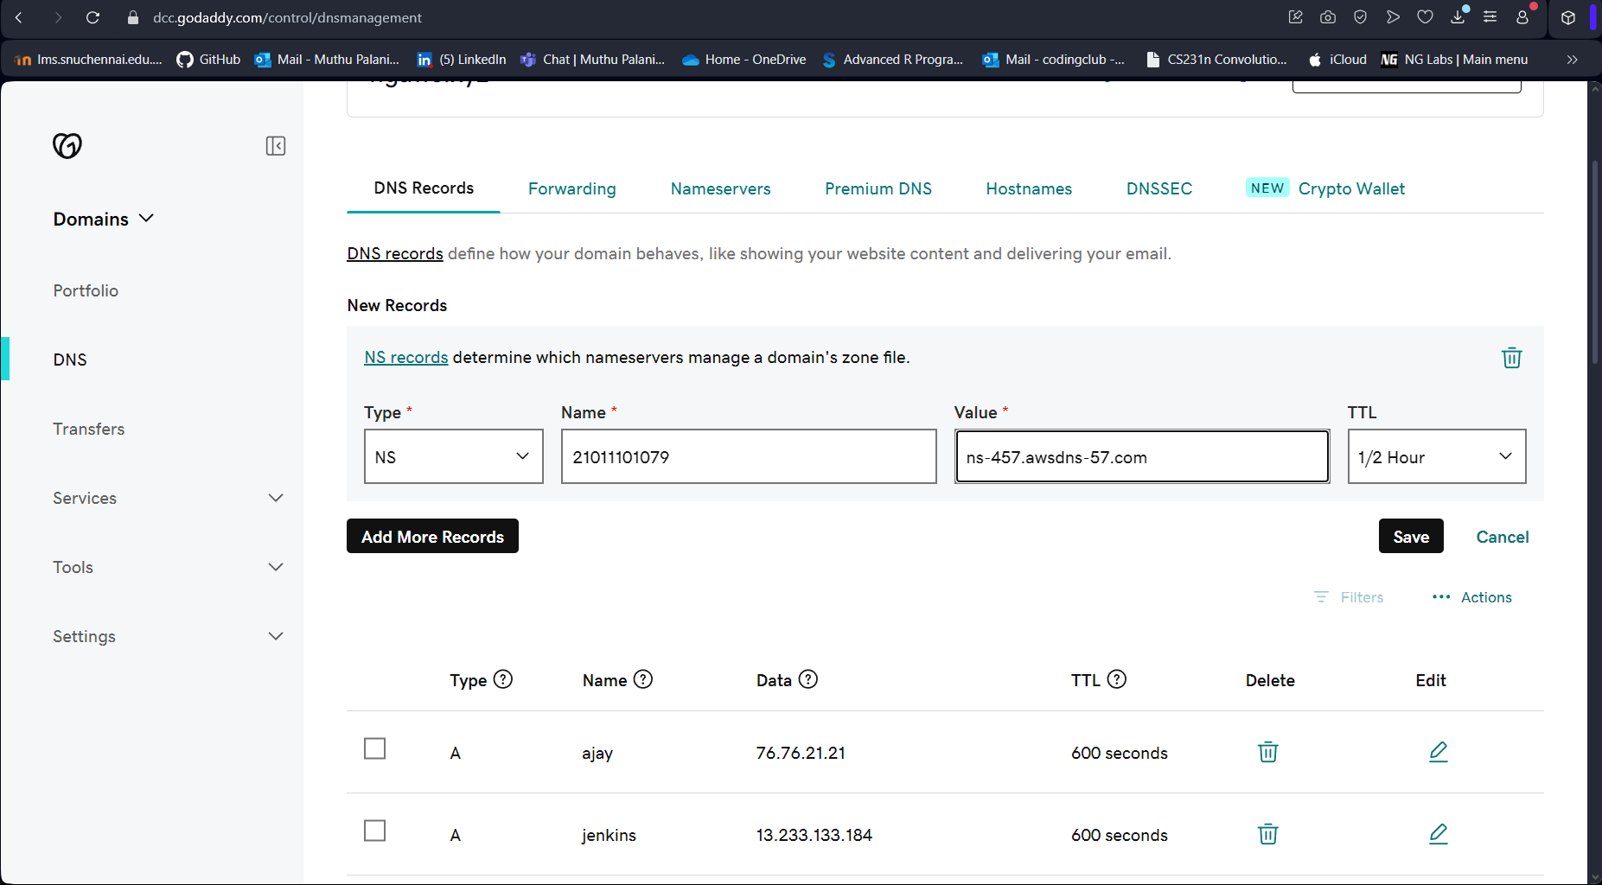

**Result:** Thus, using Route 53 service in AWS, we have successfully mapped DNS

|  |  |
| --- | --- |
| **Ex. No: 11** | **IAM** |
| **8th October** |

**Aim: To understand the working of IAM service in AWS**

**Program:**

**Create IAM Groups**

* Create a group named server admin and attach a policy for full access to EC2.
* Create a group named dns admin and attach a policy for full access to Route 53.

**Add Users to Groups**

* Create IAM users alice and bob, and add them to the server admin group.
* Create IAM users cathy and david, and add them to the dns admin group.

**Create a Billing User**

* Create IAM user eve and attach a policy to provide billing access.

**Create an Admin User**

* Create IAM user Akshay S Gand attach a policy for full access to all services.

**Create Account Alias**:

* Create an alias for your account in the IAM console.
* Use the alias URL to log in instead of the account ID.

**Output:**

**Result:** Thus, using AWS, we understand how IAM works